/// Pascal Triangle
ll C[31][31];
void buildPascal(){
for(int i = 0; i <= 30; i++)
for(int j = 0; j <= i; j++){
if(j == 0)C[i][j] =1;
else C[i][j] = C[i-1][j] + C[i-1][j-1];
}
}

2D cumulative sum:
Rule: (p-1)%p=p-1 such that p is prime
long long binpow(long long a, long long b, long long m) {
// a power b mod m
a %= m;
long long res = 1;
while (b) {
if (b & 1)
res = res * a % m;
a = a * a % m;
b >>= 1;
}
return res;
}

- ll nCr(ll n, ll r) {
- long long p = 1, k = 1;
- if (n - r < r)
- r = n - r;
- if (r != 0) {
- while (r) {
- p *= n;
- k *= r;
- long long m = __gcd(p, k);
- p /= m;
- k /= m;

- n--;
- r--;
- }
- }

- else
- p = 1;
- return p;
- }

ll gcd(ll a, ll b){
if (b == 0)
return a;
return gcd(b, a % b);
}

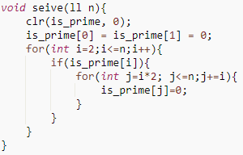
ll countDiv(ll n)
{
// Note: counting include n
ll cnt = 0;
for (int i = 1; i <= sqrt(n); i++) {
if (n % i == 0) {
if (n / i == i)
cnt++;
else
cnt = cnt + 2;
}
}
return cnt;
}
Prime Factorization using Sieve O(log n) for multiple queries
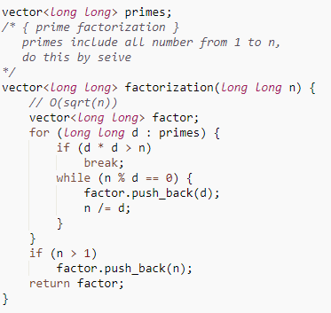
void primeFactors(int n)
{
// Print the number of 2s that divide n
while (n % 2 == 0)
{
cout << 2 << " ";
n = n/2;
}

// n must be odd at this point. So we can skip
// one element (Note i = i +2)
for (int i = 3; i <= sqrt(n); i = i + 2)
{
// While i divides n, print i and divide n
while (n % i == 0)
{
cout << i << " ";
n = n/i;
}
}

// This condition is to handle the case when n
// is a prime number greater than 2
if (n > 2)
cout << n << " ";
}

Divisibility
2 => if last of number is even (0, 2, 4, 6, 8).
3 => if the sum of all the individual digits is evenly divisible by 3.
4 => last two digit (e.g. 3628 is divisible by 4 because 28 divisible by 4).
5 => if the last digit of the number is 0 or 5.
6 => if they are evenly divisible by both 2 AND 3.
7 => to determine if a number is divisible by 7, take the last digit of the number, double it and subtract the doubled number from the remaining number.
If the result is evenly divisible by 7 (e.g. 14, 7, 0, -7, etc.), then the number is divisible by seven. This may need to be repeated several times.
Example: Is 3101 evenly divisible by 7 ?
310 - take off the last digit of the number which was 1
-2 - double the removed digit and subtract it
308 - repeat the process by taking off the 8
-16 - and doubling it to get 16 which is subtracted
14 - the result is 14 which is a multiple of 7
8 => last three digit or less
9 => sum of digit divisible by 9
10 => last digit equal zero '0'

***Strings***
const int MAX_CHAR = 26;
struct trie {
trie* child[MAX_CHAR];
bool isLeaf;

trie() { memset(child, 0, sizeof(child));
isLeaf = 0; }
void insert(char *str) {
if(*str == '\0') isLeaf = 1;
else { int cur = *str - 'a';
if(child[cur] == 0 ) child[cur] = new trie();
child[cur]->insert(str+1); }
}

bool wordExist(char* str) {
if(*str == '\0')return isLeaf;
int cur = *str - 'a';
if(child[cur] == 0 ) return false; // such path don't exist
return child[cur]->wordExist(str+1);
}
bool prefixExist(char* str) {
if(*str == '\0') return true;
int cur = *str - 'a';
if(child[cur] == 0 ) return false; // such path don't exist
return child[cur]->prefixExist(str+1);
}
};
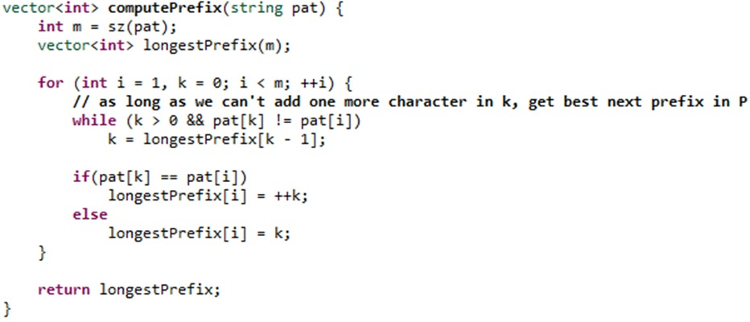

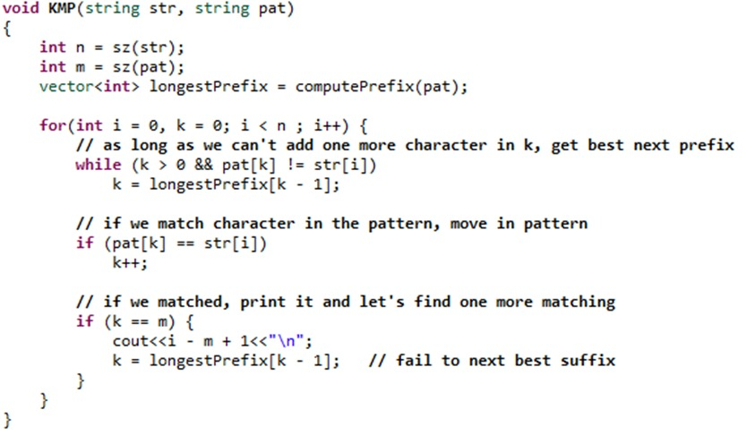

***Graph***
#define MAXNODES 100000+9
#define PB push_back
typedef vector<int> vi;
typedef pair<int, int> pii;
typedef vector<pii> vii;

//Shortest path in wighted graphs (Dijkstra)

vector<pii> Dijkstra(int src, const vector<vii> &edges) ///<Neighbor, edgeCost>
{
int N = edges.size();

vi parent(N), cost(N, INF);
vector<bool> expanded(N, false);
parent[src] = src;
cost[src] = 0;
///Queue pairs: (cost of a node, the node)
priority_queue<pii, vii, greater<pii>> q;
q.push(make_pair(0, src)); ///<totalCost, node>
while(!q.empty())
{
int node = q.top().second;
q.pop();
///If this node has been expanded before.
if(expanded[node]) continue;
else expanded[node] = true;
for(int i = 0; i < (int)edges[node].size(); i++)
{
pii edge = edges[node][i];
int neighbor = edge.first, EdgeCost = edge.second;
if(cost[node] + EdgeCost < cost[neighbor])
{
parent[neighbor] = node;
cost[neighbor] = cost[node] + EdgeCost;
q.push(make_pair(cost[neighbor], neighbor));
}
}
}
vii result(N);
for(int i = 0; i < N; i++) result[i] = make_pair(cost[i], parent[i]); ///<Least cost,parent>
return result;
}

// Minimum spanning tree ( Kruskal )

vector<int> parent, rank_;
/// Nodes number....
void make_set(int v) {
parent[v] = v;
rank_[v] = 0;
}

int find_set(int v) {
if (v == parent[v])
return v;
return parent[v] = find_set(parent[v]);
}

void union_sets(int a, int b) {
a = find_set(a);
b = find_set(b);
if (a != b) {
if (rank_[a] < rank_[b])
swap(a, b);
parent[b] = a;
if (rank_[a] == rank_[b])
rank_[a]++;
}
}

struct Edge {
int u, v, weight;
bool operator<(Edge const& other) {
return weight < other.weight;
}
};

int n=1000; /// Number of nodes...
int cost = 0; ///Total cost of the tree...
vector<Edge> Kruskal(vector<Edge>& edges){ /// Put Edges of graph here..
vector<Edge> result;
parent.resize(n);
rank_.resize(n);
for (int i = 0; i < n; i++)
make_set(i);

sort(edges.begin(), edges.end());

for (Edge e : edges) {
if(find_set(e.u) != find_set(e.v)){
cost += e.weight;
result.push_back(e);
union_sets(e.u, e.v);
}
}
return result;
}

// Graph Traverse (DFS)

vector<vi> edges(MAXNODES);
bool visited[MAXNODES];

void dfs(int node)
{
visited[node] = true;
for(int neighbor: edges[node]) if(!visited[neighbor])
{
dfs(neighbor);
}
}
// ( DSU )

struct DSU
{
int parent[MAXNODES];
int GroupSize[MAXNODES];
DSU() {
for(int i = 0; i < MAXNODES; i++) {
parent[i] = i;
GroupSize[i] = 1;
}
}
int FindLeader(int i)
{
if(parent[i] == i) return i;

return parent[i] = FindLeader(parent[i]);
}
bool SameGroup(int x, int y) {
int leader1 = FindLeader(x);
int leader2 = FindLeader(y);
return leader1 == leader2;
}
void MergeGroups(int x, int y)
{
int leader1 = FindLeader(x);
int leader2 = FindLeader(y);
if (leader1 == leader2) return;
if (GroupSize[leader1] > GroupSize[leader2])
{
parent[leader2] = leader1;
GroupSize[leader1] += GroupSize[leader2];
}
else {
parent[leader1] = leader2;
GroupSize[leader2] += GroupSize[leader1];
}
}
int GetSize(int x)
{ int leader = FindLeader(x);
return GroupSize[leader]; }
};
/// Shortest path in unweighted graph (BFS)

vector<vi> edges(MAXNODES); ///adjacency list
vi distances(MAXNODES, -1);
vi p(MAXNODES);

void BFS(int src)
{
distances[src] = 0;
p[src] = src;

queue<int> q;
q.push(src);

while(!q.empty())
{
int node = q.front(); q.pop();
int cost = distances[node];

for(int child: edges[node]) if(distances[child]== -1)
{
p[child] = node;
q.push(child);
distances[child] = cost+1;
}
}
}

///For the graph in the picture, with src = 1.

//distances = 0 , 1 , 2 , 2 , 1
//p = 1 , 1 , 2 , 2 , 1

vector<int> path(){
v.PB(dest); ///3 2 1 //dest is the destination node ...
int node = dest;
do{
if(p[node]==0){
v.clear();
return v;
}
node = p[node];
v.PB(node);

}while(node != src);

reverse(v.begin(), v.end());
return v;
}
struct edge {
int from, to, w;

edge(int from, int to, int w): from(from), to(to), w(w) {}

bool operator < (const edge & e) const {
return w > e.w;
}
};

int Dijkstra2(vector< vector< edge > > adjList, int src, int dest = -1) // O(E logV)
{
int n = sz(adjList);
vi dist(n, OO), prev(n, -1);
dist[src] = 0;

priority_queue<edge> q;
q.push( edge(-1, src, 0) );

while( !q.empty() ) {
edge e = q.top(); q.pop();

if(e.w > dist[e.to]) continue; // some other state reached better

prev[ e.to ] = e.from;

rep(j, adjList[e.to]) {
edge ne = adjList[e.to][j];
if( dist[ne.to] > dist[ne.from] + ne.w ) {
ne.w = dist[ne.to] = dist[ne.from] + ne.w;
q.push( ne );
}
}
}

return dest == -1 ? -1 : dist[dest];
}
Print all cycle in graph
// C++ program to print all the cycles
// in an undirected graph
#include <bits/stdc++.h>
using namespace std;
const int N = 100000;

// variables to be used
// in both functions
vector<int> graph[N];
vector<int> cycles[N];

// Function to mark the vertex with
// different colors for different cycles
void dfs_cycle(int u, int p, int color[],
int mark[], int par[], int& cyclenumber)
{

// already (completely) visited vertex.
if (color[u] == 2) {
return;
}

// seen vertex, but was not completely visited -> cycle detected.
// backtrack based on parents to find the complete cycle.
if (color[u] == 1) {

cyclenumber++;
int cur = p;
mark[cur] = cyclenumber;

// backtrack the vertex which are
// in the current cycle thats found
while (cur != u) {
cur = par[cur];
mark[cur] = cyclenumber;
}
return;
}
par[u] = p;

// partially visited.
color[u] = 1;

// simple dfs on graph
for (int v : graph[u]) {

// if it has not been visited previously
if (v == par[u]) {
continue;
}
dfs_cycle(v, u, color, mark, par, cyclenumber);
}

// completely visited.
color[u] = 2;
}

// add the edges to the graph
void addEdge(int u, int v)
{
graph[u].push_back(v);
graph[v].push_back(u);
}

// Function to print the cycles
void printCycles(int edges, int mark[], int& cyclenumber)
{

// push the edges that into the
// cycle adjacency list
for (int i = 1; i <= edges; i++) {
if (mark[i] != 0)
cycles[mark[i]].push_back(i);
}

// print all the vertex with same cycle
for (int i = 1; i <= cyclenumber; i++) {
// Print the i-th cycle
cout << "Cycle Number " << i << ": ";
for (int x : cycles[i])
cout << x << " ";
cout << endl;
}
}

// Driver Code
int main()
{

// add edges
addEdge(1, 2);
addEdge(2, 3);
addEdge(3, 4);
addEdge(4, 6);
addEdge(4, 7);
addEdge(5, 6);
addEdge(3, 5);
addEdge(7, 8);
addEdge(6, 10);
addEdge(5, 9);
addEdge(10, 11);
addEdge(11, 12);
addEdge(11, 13);
addEdge(12, 13);

// arrays required to color the
// graph, store the parent of node
int color[N];
int par[N];

// mark with unique numbers
int mark[N];

// store the numbers of cycle
int cyclenumber = 0;
int edges = 13;

// call DFS to mark the cycles
dfs_cycle(1, 0, color, mark, par, cyclenumber);

// function to print the cycles
printCycles(edges, mark, cyclenumber);
}
ToPo : out-in degree (Ascending)

int main()
{
int t; cin >> t;
while (t--) {
int n, m;
cin >> n >> m;
vector<int> adj[102];
int node, k;
vi out_degree(n+1, 0);
set <int > order;
vi ans;
while (m--)
{
cin >> node >> k;

out_degree[node]=k;
lp(i, k) {
int child;
cin >> child;
adj[child].push_back(node);
}
}
for (int i = 1; i <= n; i++)
{
if (!out_degree[i])order.insert(i);
}
while (!order.empty())
{
int cur = *order.begin();
for (int parent : adj[cur]) {
out_degree[parent]--;
if (!out_degree[parent])order.insert(parent);
}
ans.push_back(cur);
order.erase(cur);

}
lp(i, n - 1)cout << ans[i] << " ";
cout << ans.back() << endl;
if (t)cout << endl;

}
return 0;
}
Number of divisors of 963761198400 = 6720

#define endl "\n"
#define ll long long
#define all(v) ((v).begin()), ((v).end())
#define sz(v) ((int)((v).size()))
#define clr(v, d) memset(v, d, sizeof(v))
#define rep(i, v) for(int i=0;i<sz(v);++i)
#define lp(i, n) for(int i=0;i<(int)(n);++i)
#define lpi(i, j, n) for(int i=(j);i<(int)(n);++i)
#define lpd(i, j, n) for(int i=(j);i>=(int)(n);--i)
#define vi vector <int>
#define vl vector <ll>
#define ii pair <ll,ll>
#define vii vector <ii>
const double PI = 2*acos(0.0);
void run() {
ios_base::sync_with_stdio(false);
cin.tie(nullptr), cout.tie(nullptr);
}
// Function to print all sub strings
void subString(string s, int n)
{
// Pick starting point in outer loop
// and lengths of different strings for
// a given starting point
for (int i = 0; i < n; i++)
for (int len = 1; len <= n - i; len++)
cout << s.substr(i, len) << endl;
}

- #include "bits/stdc++.h"

- using namespace std;

- #define ll long long int
- #define inf (ll)1e17

- static const int maxn = 100 + 5;
- static const int Max = 1e5 + 5;

- ll dp[maxn][Max];
- bool memoize[maxn][Max];

- int w[maxn], val[maxn];

- int N, W;

- ll solve(int pos, int make)
- {
- if (pos >= N)
- {
- if (make == 0) return 0;
- return inf;
- }
- ll &ret = dp[pos][make];
- bool &mem = memoize[pos][make];
- if (mem) return ret;
- mem = 1;
- ret = inf;
- if (make - val[pos] >= 0) ret = min(ret, w[pos] + solve(pos+1, make - val[pos]));
- ret = min(ret, solve(pos+1, make));
- return ret;
- }

- int main()
- {
- scanf("%d %d", &N, &W);
- for (int i = 0; i < N; i++) scanf("%d %d", &w[i], &val[i]);
- for (int make = 100000; make >= 0; make--)
- {
- ll ans = solve(0, make);
- if (ans <= W)
- {
- printf("%d\n", make);
- break;
- }
- }
- }

- // int dr[] = {1, -1, 0, 0}; // 4 Direction
- // int dc[] = {0, 0, 1, -1};
- // int dr[] = {0, 0, 1, -1, 1, 1, -1, -1}; // 8 Direction
- // int dc[] = {1, -1, 0, 0, 1, -1, 1, -1};
- // int dr[] = {-1, 1, -2, -2, -1, 1, 2, 2}; // knight Moves
- // int dc[] = {-2, -2, -1, 1, 2, 2, 1, -1};
const int N = 1e5 + 1;
int sz[N] , p[N];
void init(){
iota(p , p + N , 0); // 0 1 2 3 .. N
fill(sz , sz + N , 1);
}
int f(int u){
return p[u] = (p[u] == u ? u : f(p[u]));
}
void unite(int u , int v){
u = f(u);
v = f(v);
if(u == v)return;
if(sz[v] < sz[u])swap(u , v);
p[u] = v;
sz[v] += sz[u];
}

**Inversions in nlog(n)**

ll _mergeSort(int arr[], int temp[],int left, int right);
ll merge(int arr[], int temp[], int left,int mid, int right);
ll mergeSort(int arr[], int array_size)
{
int temp[array_size];
return _mergeSort(arr, temp, 0, array_size - 1);
}
ll _mergeSort(int arr[], int temp[],
int left, int right)
{
ll mid, inv_count = 0;
if (right > left) {
mid = (right + left) / 2;
inv_count += _mergeSort(arr, temp,
left, mid);
inv_count += _mergeSort(arr, temp,
mid + 1, right);
inv_count += merge(arr, temp, left,
mid + 1, right);
}
return inv_count;
}
ll merge(int arr[], int temp[], int left,
int mid, int right)
{
int i, j, k;
ll inv_count = 0;
i = left;
j = mid;
k = left;
while ((i <= mid - 1) && (j <= right)) {
if (arr[i] <= arr[j]) {
temp[k++] = arr[i++];
}
else {
temp[k++] = arr[j++];
inv_count = inv_count + (mid - i);
}
}
while (i <= mid - 1)
temp[k++] = arr[i++];
while (j <= right)
temp[k++] = arr[j++];
for (i = left; i <= right; i++)
arr[i] = temp[i];
return inv_count;
}
expo. Matrix
/*
* new_a = x1*a+x2*b
* new_b = x3*a+x4*b
* a = {{x1,x2}, {x3,x4}}
*/
void mul(vector<vl> &a,vector<vl> &b) {
ll m[2][2]={{0,0},{0,0}};
for (int i = 0; i < 2; i++) {
for (int j = 0; j < 2; ++j) {
for (int k = 0; k < 2; ++k) {
m[i][k] += a[i][j] * b[j][k];
m[i][k] %= mod;
}
}
}
for (int i = 0; i < 2; i++) {
for (int j = 0; j < 2; ++j) {
a[i][j] = m[i][j];
}
}
}
vector<vl> ans(2,vl(2));
void exp_power(vector<vl> a,ll n){
ans = {{1,0},{0,1}};
while(n>0){
if(n%2){
mul(ans,a);
}
mul(a,a);
n/=2;
}
}

